Layaan Isaacs

website propsoal 1
Contents
Index 3
Website Project Proposal 1 6
1. Organisation Overview 6
Mission Statement 7
Vision Statement 7
Target Audience 7
2. Website Goals and Objectives 8
Objectives include: 8
Key Performance Indicators (KPIs) 8
3. Current Website Analysis 9
Strengths 9
Weaknesses 9
Areas for Improvement 9
4. Proposed Website Features and Functionality 10
5. Design and User Experience 11
Colour Scheme 11
Typography 11
Layout and Design 11
User Experience Considerations 11
6. Technical Requirements 12
7. Timeline and Milestones 12
8. Budget 12
References 13

Index
Section | Page Number
Cover Page | 1
Table of Contents | 2
1. Introduction | 3
2. Purpose of the Website | 4
3. Target Audience | 5
4. Description of Web Pages | 6
4.1 Home Page | 6
4.2 Services Page | 7
4.3 Gallery Page | 8
4.4 Booking Page | 9
4.5 Contact Page | 10
5. Budget for Each Web Page | 11
6. Conclusion  7. References | 12

Flowchart

Gallery
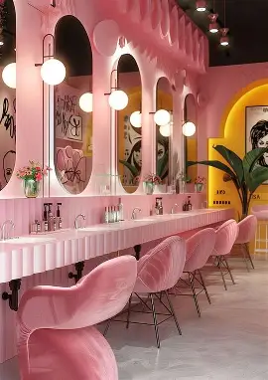
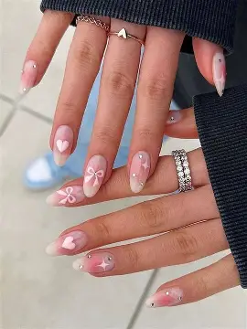

Website Project Proposal 1
Target Organisation: Blossom Beauty (Salon)

1. Organisation Overview
Name: Blossom Beauty
Blossom Beauty is a modern beauty salon that provides professional beauty services such as hair styling, nail treatments, makeup applications, and skincare treatments. The salon focuses on helping clients look and feel confident by offering high-quality beauty services in a welcoming and relaxing environment.
Blossom Beauty was created to provide a convenient place where clients can access multiple beauty services in one location. The salon focuses on professional customer service and keeping up with modern beauty trends to ensure that clients receive stylish and high-quality results.
Currently, the salon mainly promotes its services through word-of-mouth and social media platforms where it shares pictures of hairstyles, nail designs, and beauty transformations. However, the business would like to expand its online presence by developing a professional website where customers can view services, learn more about the salon, and make enquiries.
Mission Statement
The mission of Blossom Beauty is to provide professional beauty services that help clients feel confident, stylish, and well cared for.

Vision Statement
The vision of Blossom Beauty is to grow into a recognised beauty salon known for excellent service, creativity, and customer satisfaction.

Target Audience
The target audience includes:
- Women aged 16–45
- Clients interested in hair styling, nails, and beauty treatments
- People preparing for special events such as weddings or parties
- Local customers looking for reliable beauty services

2. Website Goals and Objectives
The main goal of the Blossom Beauty website is to create a professional online platform that showcases the salon and its services.

Objectives include:
- Promoting the salon and its beauty services
- Allowing customers to view available treatments and pricing
- Providing information about the salon and its staff
- Allowing customers to contact the salon for bookings or enquiries

Key Performance Indicators (KPIs)
Success of the website will be measured through website traffic and customer enquiries.
Visitor tracking will be implemented using Google Analytics once the website is published. This will allow the business to monitor the number of visitors, page views, and how users interact with the website.

3. Current Website Analysis
Currently, Blossom Beauty does not have an official website and mainly relies on social media to promote its services.

Strengths
- Strong visual content from beauty transformations
- Existing social media audience
- Popular beauty services

Weaknesses
- No professional website
- Limited information available for new customers
- Clients cannot easily view all services in one place

Areas for Improvement:
- A professional online presence
- Better presentation of salon services
- Easier communication between clients and the salon

4. Proposed Website Features and Functionality
The Blossom Beauty website will include the following pages:
Homepage (index.html)
A welcoming landing page introducing the salon with an image of the salon and navigation to other pages.
About Page (about.html)
Information about the salon, its mission, and the team.
Services Page (services.html)
A page listing all beauty services such as hair styling, nail treatments, facials, and makeup.
Gallery Page (gallery.html)
A display of images showing hairstyles, nail designs, and beauty results.
Contact Page (contact.html)
Contact details, location information, and a form for customers to make enquiries or bookings.

5. Design and User Experience

Colour Scheme
The website will use the following colours:
- Soft pink
- White
- Gold
These colours represent beauty, elegance, and professionalism.

Typography
Headings will use stylish and elegant fonts while body text will use clear and readable fonts such as Arial.

Layout and Design
The website will have a clean and modern layout with large images to highlight beauty services.

User Experience Considerations
- Easy navigation between pages
- Clear display of services
- Mobile-friendly layout
- Fast loading pages
Low-fidelity wireframes will be created to plan the page layout.

6. Technical Requirements
The website will be developed using HTML to demonstrate basic web development skills.
The project will require a domain name such as blossombeauty.co.za and web hosting services to make the website accessible online.

7. Timeline and Milestones
Week 1 – Proposal and planning
Week 2 – Research and gathering images
Week 3 – Planning website structure and sitemap
Week 4 – Creating HTML pages
Week 5 – Testing and final improvements

8. Budget
Domain registration: R150 per month
Web hosting: R1200 per year
Website development: R5000 once off
Maintenance: R2000 per year
Estimated total: R8350

References
- Beauty Industry Group (2024) Beauty industry trends and insights. Available at: https://beautyindustrygroup.com (Accessed: 1 April 2026).
- Statista (2023) Beauty & personal care market statistics. Available at: https://www.statista.com (Accessed: 1 April 2026).
- L'Oréal (2024) Beauty trends and innovation. Available at: https://www.loreal.com (Accessed: 1 April 2026).
- Vogue (2023) Latest beauty trends. Available at: https://www.vogue.com (Accessed: 1 April 2026).
- Mindbody (2024) Spa and salon industry report. Available at: https://www.mindbodyonline.com (Accessed: 1 April 2026).

